Data Analytics With Tableau

Name : N.Syam Surya
Team Member – 3 Assignment - 3

Supermarket Sales Data Analysis Report – Interactive Dashboard using Tableau

Objective:
This dashboard analyzes historical sales data from a supermarket chain across three branches (A, B, C) over a 3-month period. It provides visual insights into sales trends, customer behavior, and performance by product category.
Process Followed:
- Uploaded Dataset to Tableau from Excel.
- Removed unnecessary columns.
- Created visualizations:
  - Bar Chart
  - Pie Chart
  - Stacked Bar Chart
  - Line Chart
  - Bubble Chart
  - Donut Chart
  - Area Chart
  - Text Table
  - Highlighted Table

  - WordCloud
  - Funnel Chart
  - Waterfall
  - KPI Tiles
- Combined visualizations into a single interactive dashboard.

Dashboard:
Super Market Sales dashboard:
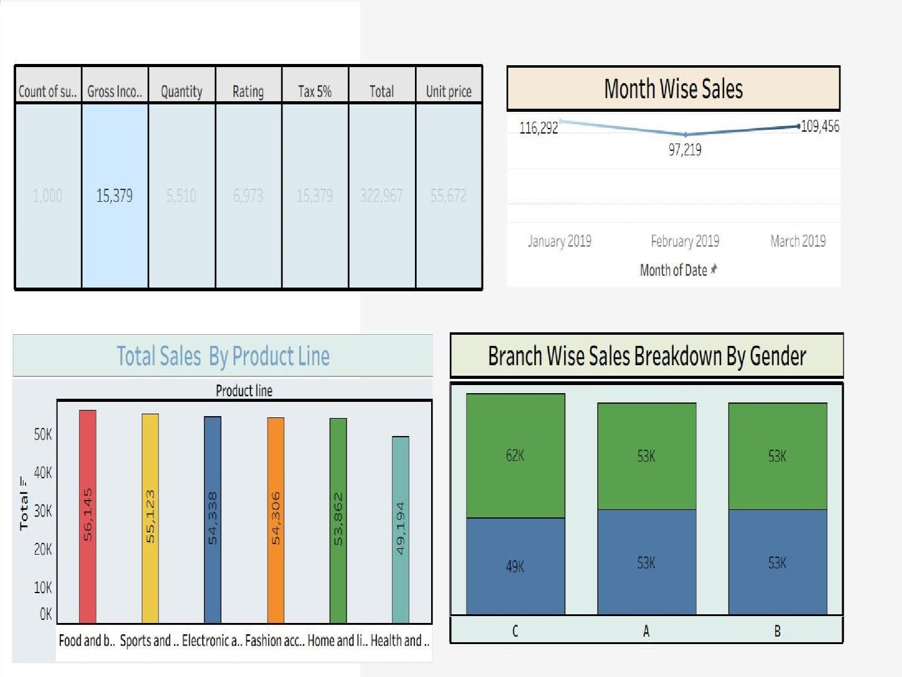

Super Market Sales dashboard:

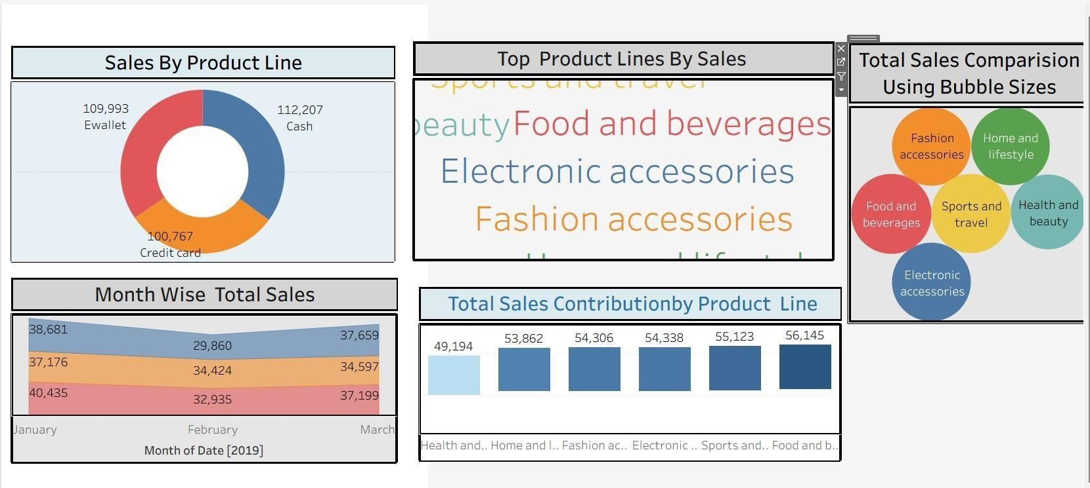

Super Market Sales dashboard:

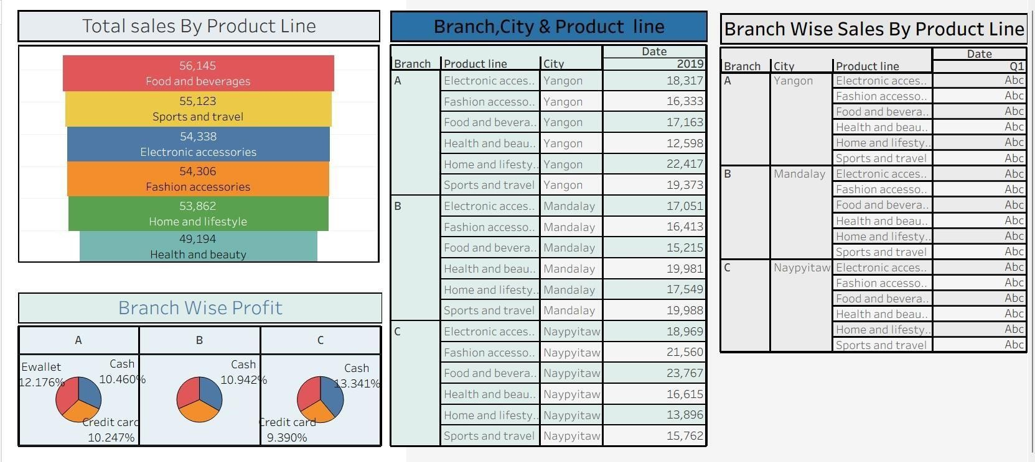

Conclusion:
This interactive dashboard made it easy to understand which products and
branches performed best. It also helped identify differences between member and normal customers. These insights can be really useful for planning offers, improving customer experience, and making better business decisions based on data.

